- Press release –
EDP awards at FESPA Global Print Expo 2019
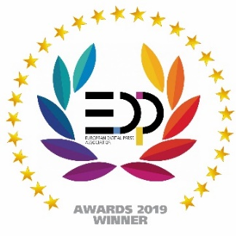
ORIS X Gamut recognized as the “Best Color Management Solution”
Hainburg (Germany), 15 May 2019. Launched only a few months ago but already making quite a stir in the marketplace, ORIS X Gamut, the latest color management software from CGS, has received the European Digital Press (EDP) Award for the “Best Color Management Software” in the Software/Color Management Solutions category.
Bernd Rückert, CGS Product Marketing Manager, accepted the prize at the FESPA show in Munich. “We are very pleased that our latest product won the competition and was recognized as a major contributor to the optimization of printing processes at many companies, together with its outstanding integration within customers’ existing workflows.”
The award was presented by the EDP Technical Committee. The focus of the judges were innovation, quality, performance and cost effectiveness. “It’s about technical criteria, not popularity,” explains Klaus-Peter Nicolay, President of the EDP Association, and that no public or outside voting can influence the judging. “Only then can the EDP Association guarantee that the best products are chosen and that the performance of the manufacturer in the development of new technologies is recognized.” One of the EDP Association’s goals is to support industry members in their task to find the right solutions for their applications, acting both as an information source and for recommendations for purchase.
The jury commented: “Seven-color (or multi-color) printing is becoming increasingly popular. ORIS X Gamut is the perfect tool to support both digital and offset printing as well as a hybrid environment”.
ORIS X Gamut extends CGS’s product line into fully automatic software making it possible to reproduce special colors on multi-color conventional and digital presses using an extended, fixed, ink set. This simple and reliable process also produces a richer, saturated, color image for a more brilliant photo-reproduction for, e.g., photobooks (RGB).
In addition, the converted color data can be the basis for automatic decision making in the production process, enabling ORIS X Gamut to contribute significantly to workflow optimization and error reduction.

About the European Digital Press Association and their Awards
The EDP Awards are the only European technical competition in the industry. The EDP was founded in 2006 by six trade magazines with main editorial focus on digital print and production. Now the EDP Association counts 21 member magazines all over Europe, covering 27 countries and reaching more than half a million of readers. Highlight of the year are the popular EDP Awards recognizing the best products of the year in five main categories.
Experts from the EDP evaluate the latest products and technology from categories such as Hardware, Software, Large/Wide Format Printing, Commercial Printing, Industrial Applications, Finishing and Consumables. The best product in each category is presented with an EDP Award.
The 68-page “EDP Report 2019” lists the results of this years’ competition with all the products that were evaluated. It can be ordered in printed form from nico@edp-award.com and will available from 20th May as a PDF download on the EDP web site: www.edp-awards.org.

About CGS
CGS Publishing Technologies International GmbH, founded in Hainburg in 1985, is a global leader of color management solutions, digital proofing systems and specially formulated media. Headquartered near Frankfurt (Germany), CGS also has operations in the United States, Japan and many other countries, as well as sales and support partners throughout the world. Further information on CGS and all ORIS products can be found on our web site www.cgs-oris.com as well as on Facebook and LinkedIn.

